**Marcos Eduardo Campos Covarrubias**

**HW1_AP**

**Software Development Life Cycle**

1. **Research about Flipped Learning**

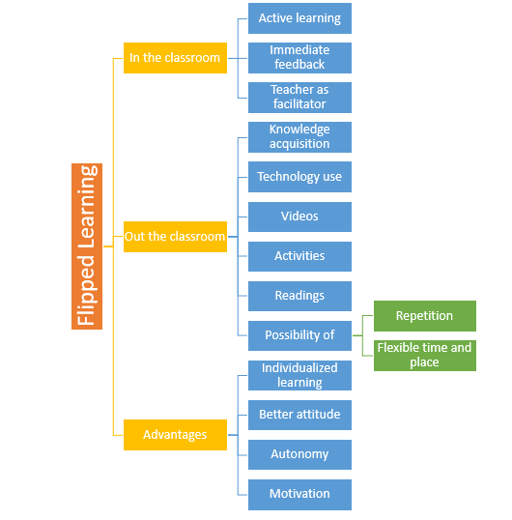

1. **Research the following concepts:**

**1. Define the concept of Software Development Life Cycle (SDLC).**

What is the Software Development Life Cycle?

A software development life cycle (SDLC) model is a conceptual framework describing all activities in a software development project from planning to maintenance. This process is associated with several models, each including a variety of tasks and activities.

Software development is a cumbersome activity requiring proper identification of requirements, their implementation, and software deployment. However, the activities do not end there. After the distribution of the software, proper maintenance has to be provided in a timely manner.

This term is also known as the software development process model.their customers’ needs. SDLC helps achieve these goals by identifying inefficiencies and higher costs and fixing them to run smoothly.

**2. Describe the elements of SDCL**

1) Requirement Gathering and Analysis

During this phase, all the relevant information is collected from the customer to develop a product as per their expectation. Any ambiguities must be resolved in this phase only.

Business analyst and Project Manager set up a meeting with the customer to gather all the information like what the customer wants to build, who will be the end-user, what is the purpose of the product. Before building a product a core understanding or knowledge of the product is very important.

For Example, A customer wants to have an application which involves money transactions. In this case, the requirement has to be clear like what kind of transactions will be done, how it will be done, in which currency it will be done, etc.

Once the requirement gathering is done, an analysis is done to check the feasibility of the development of a product. In case of any ambiguity, a call is set up for further discussion.

Once the requirement is clearly understood, the SRS (Software Requirement Specification) document is created. This document should be thoroughly understood by the developers and also should be reviewed by the customer for future reference.

2) Design

In this phase, the requirement gathered in the SRS document is used as an input and software architecture that is used for implementing system development is derived.

3) Implementation or Coding

Implementation/Coding starts once the developer gets the Design document. The Software design is translated into source code. All the components of the software are implemented in this phase.

4) Testing

Testing starts once the coding is complete and the modules are released for testing. In this phase, the developed software is tested thoroughly and any defects found are assigned to developers to get them fixed.

Retesting, regression testing is done until the point at which the software is as per the customer’s expectation. Testers refer SRS document to make sure that the software is as per the customer’s standard.

5) Deployment

Once the product is tested, it is deployed in the production environment or first UAT (User Acceptance testing) is done depending on the customer expectation.

In the case of UAT, a replica of the production environment is created and the customer along with the developers does the testing. If the customer finds the application as expected, then sign off is provided by the customer to go live.

6) Maintenance

After the deployment of a product on the production environment, maintenance of the product i.e. if any issue comes up and needs to be fixed or any enhancement is to be done is taken care by the developers.

**3. Describe with your own words the importance of SDLC.**

Its importance lies in reducing the number of design weaknesses and code errors, so it allows to carry out the projects and avoid the excessive growth of the software and that the processes get out of control, the result is a more secure and reliable software.